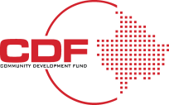
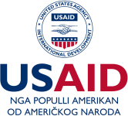

Legalities and Compliance Checklist for MSMEs in Kosovo

General Compliance

◻ Register your business and obtain necessary licenses.
◻ Ensure your business practices align with Kosovo’s Law on Business Organizations.
◻ Familiarize yourself with the local, national, and international laws affecting your industry.

Employee Contracts

◻ Draft employment contracts in accordance with Kosovo’s labor laws.
◻ Specify roles, responsibilities, and remuneration clearly.
◻ Include clauses for termination and data protection in line with legal requirements.

Employee Benefits and Family Rights

◻ Provide paid vacations, sick leave, and other mandatory benefits.
◻ Adhere to maternity and paternity leave policies.
◻ Ensure equal treatment and non-discrimination in the workplace.

Data Privacy and GDPR

◻ Familiarize yourself with Kosovo’s Law No. 06/L-082 on Personal Data Protection.
◻ Implement data protection measures aligned with GDPR.
◻ Appoint a Data Protection Officer if required.

Employee Termination and Data Protection

◻ Clearly define grounds for termination in employment contracts.
◻ Ensure data protection protocols are maintained during the termination process.
◻ Adhere to the employee rights post-termination.

Occupational Safety and Health (OSH)

◻ Conduct risk assessments for all work tasks.
◻ Stay updated with OSH laws and ensure compliance.
◻ Provide regular OSH training to employees.

Future Legislation

◻ Keep an eye on any updates or revisions regarding Kosovo’s “Intersectoral Strategy on Safety and Health at Work 2021–2026” and its Action Plan for 2021–2023.
◻ Regularly update your policies to align with new legislation.

