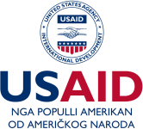
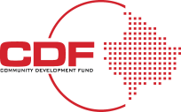

CHECKLIST: Essential Steps for Business Registration in Kosovo
Description of Steps | Checkbox
Initial Planning Phase
Research the market for your business idea | ☐
Develop a business plan | ☐
Select a business structure (e.g., Sole Proprietor, LLC, Corporation) | ☐
Identify a business name and perform a name check | ☐
Legal Requirements
Register the business name | ☐
Obtain necessary business licenses and permits | ☐
Draft business contracts and agreements | ☐
Financial Preparations
Open a dedicated business bank account | ☐
Create a preliminary business budget | ☐
Evaluate initial investment needs | ☐
Kosovo Business Registration Agency (KBRA) Steps
Submit the required documents to KBRA | ☐
Pay the registration fee | ☐
Obtain the Certificate of Business Registration | ☐
Intellectual Property
File for any patents, trademarks, or copyrights if necessary | ☐
Tax and Accounting
Register for tax identification number (TIN) | ☐
Set up accounting and bookkeeping systems | ☐
Familiarize yourself with Kosovo tax rates (Corporate: 10%, VAT: 18%) | ☐
Employee Management
Draft employment contracts | ☐
Set up payroll system | ☐
Register for social security contributions (5% Employee, 5% Employer) | ☐
Initial Operations
Develop a sales and marketing strategy | ☐
Set up a business website and online presence | ☐
Establish initial inventory and supply chain if applicable | ☐
Continuous Monitoring and Compliance
Regularly review and update business plan | ☐
Stay updated on legal and tax changes | ☐
Conduct periodic internal financial audits | ☐

